**bespire**

**ISO Registry of Geodetic Codes and Parameters**

Quick Start Guide  
Pre-release (1.2)

05 September 2014

Copyright © 2014. This software was developed by bespire UG (haftungsbeschränkt) under a contract with the Norwegian Mapping Authority (Statens kartverk).

This software uses components that were developed by Frankfurt University of Applied Sciences under a contract with the German Federal Agency for Cartography and Geodesy (Bundesamt für Kartographie und Geodäsie).

No part of this publication may be reproduced, stored in a retrieval system, or transmitted, in any form, or by any means, electronic, mechanical, photocopying, recording or otherwise, without the prior consent of the copyright owner.

Authors of this document: Sven Böhme, Florian Esser

**Contents**

1 Introduction 1

2 The online registry system 2

2.1 Providing feedback 2

2.2 Registration and login 2

2.3 Your user profile 4

3 Roles and processes in the registry 5

3.1 Register roles 5

3.2 Software roles 5

3.3 Proposals 5

3.4 Registry processes 6

4 Use cases in the registry 7

4.1 Submitting new content 7

4.2 Withdrawing a proposal 9

4.3 Proposal review by the register manager 10

4.4 Proposal review by the control body 12

4.5 Appealing the control body decision 13

5 Registry administration 15

5.1 Delegate rights 15

# Introduction

This document is a quick start guide for users of the ISO Registry of Geodetic Codes and Parameters. The goal of this guide is to help you perform tasks as a content user and content submitter.

The ISO Registry of Geodetic Codes and Parameters is a structured database of coordinate reference systems and transformations that is accessible through an on-line registry system.

This registry is provided under the auspices of ISO Technical Committee 211 on geographic information/geomatics and conforms to ISO standards ISO 19111:2007 (Spatial referencing by coordinates), ISO/TS 19127:2005 (Geodetic codes and parameters), ISO 19135:2005 (Procedures for item registration) and its soon to be published revision ISO 19135-1 (Procedures for item registration - Part 1: Fundamentals), and ISO 19135-2:2012 (Procedures for item registration -- Part 2: XML schema implementation).

Users of the registry may query and view data and generate reports via anonymous guest access. Registered users may also submit proposals for new additions or clarifications to the registry.

# The online registry system

The user interface of the online registry system displays an application menu containing links to all registry sections accessible to the user, including a list of registers and their respective contained item classes.

The content of an individual register may be browsed by clicking on the register’s name. Additionally, the register content may be filtered by item class groups or individual item classes by selecting the respective item class group or item class in the application menu.

## Providing feedback

In the pre-release version of the ISO Registry of Geodetic Codes and Parameters users may provide feedback to the developers by clicking on the blue *Provide feedback* button that is displayed on the right edge of all pages.

After clicking the *Provide feedback* button you will be presented with a dialog where you may submit technical errors or suggestions for improvement. In addition to a textual summary and description you may also attach a screenshot.

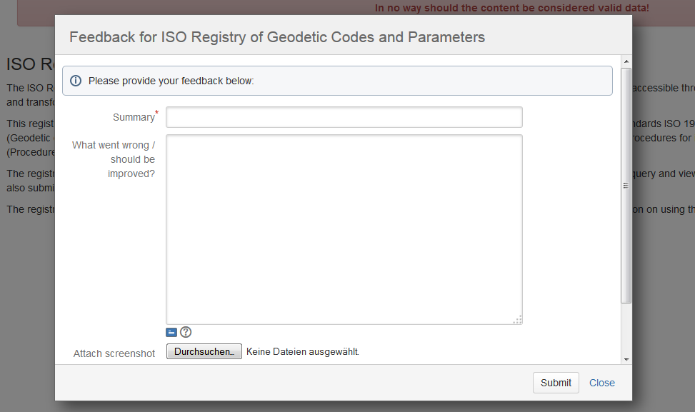

Fig. 1 – Feedback dialog

## Registration and login

In order to be able to submit new content to the ISO Registry of Geodetic Codes and Parameters, you need to create a user account and subsequently log in to the registry software.

To start the registration process, click on *Login* in the upper right corner of the page.

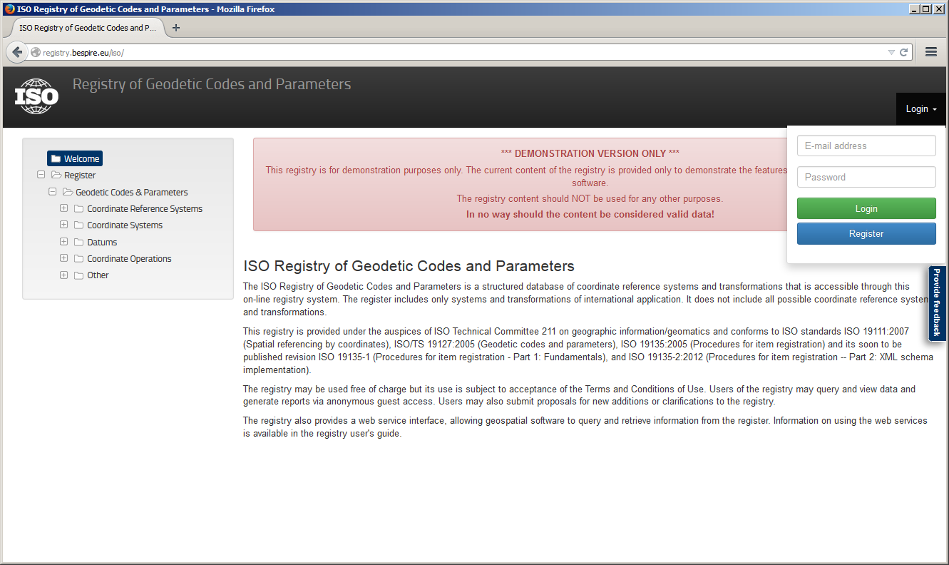

Fig. 2 - The Login dropdown

Fill out the user registration dialog and press *Sign up*. Make sure that your e-mail address is spelt correctly. If your organization is not in the list of organizations, check the *My organization is not listed* box. Enter the name of your organization on the following page and press *Save*.

You will receive an e-mail to confirm your registration. Please follow the instructions and open the contained confirmation link in your web browser.

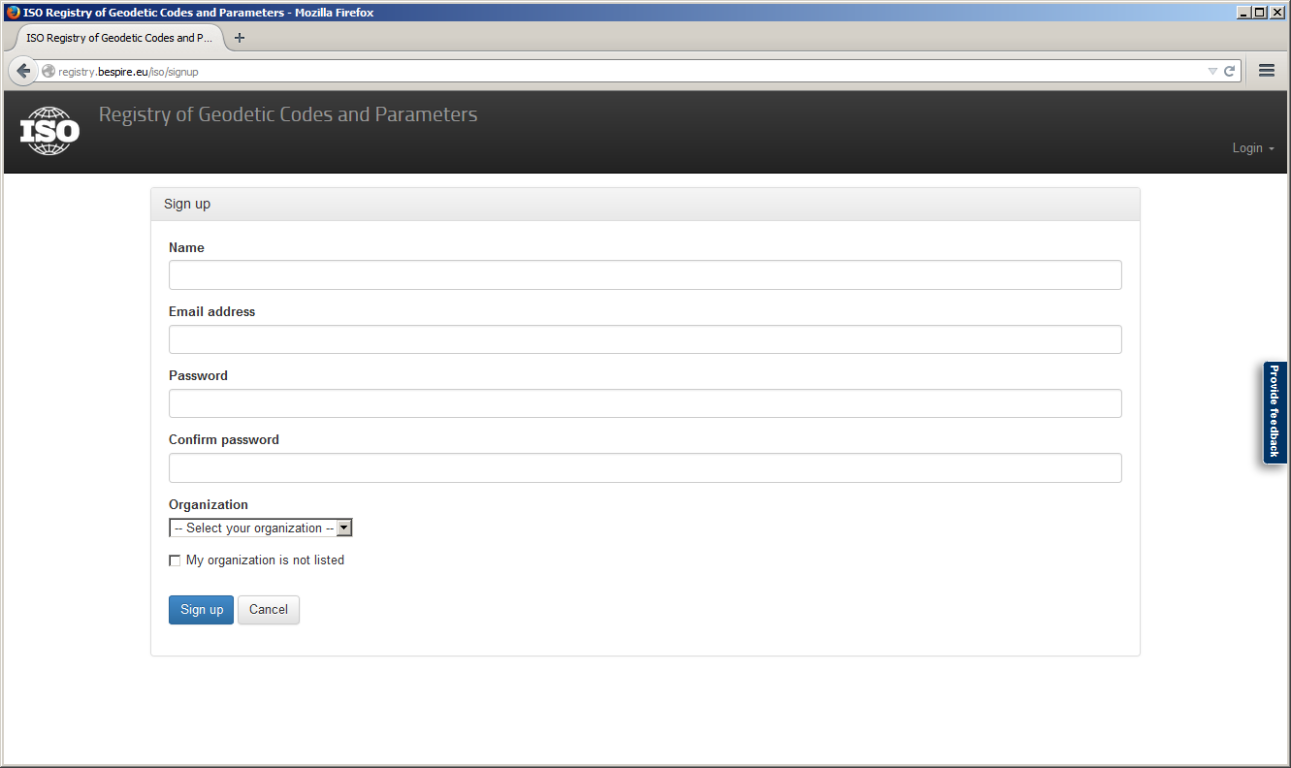

Fig. 3 - Signing up

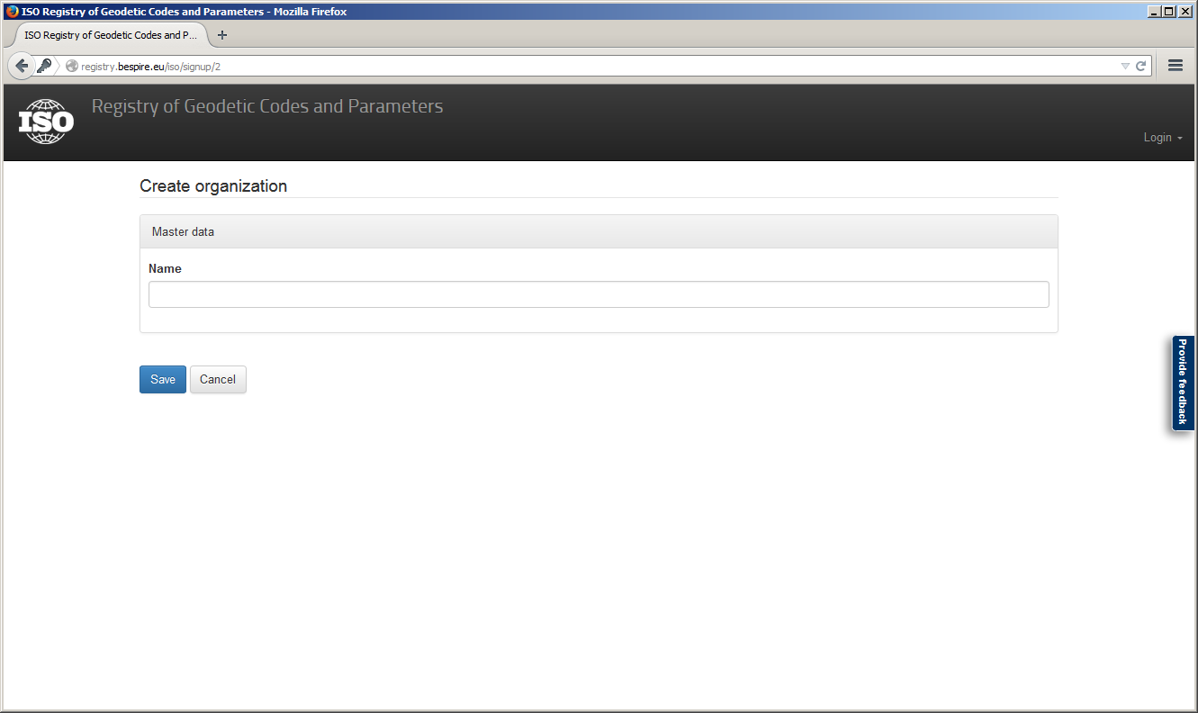

Fig. 4 - Signing up: Organization details

You may now log in to the registry by clicking on *Login* (top right), entering your e-mail address and password and pressing the *Login* button.

## Your user profile

To modify your personal user details, log in to the registry and click on *My Account* on the bottom of the application menu on the left hand side.

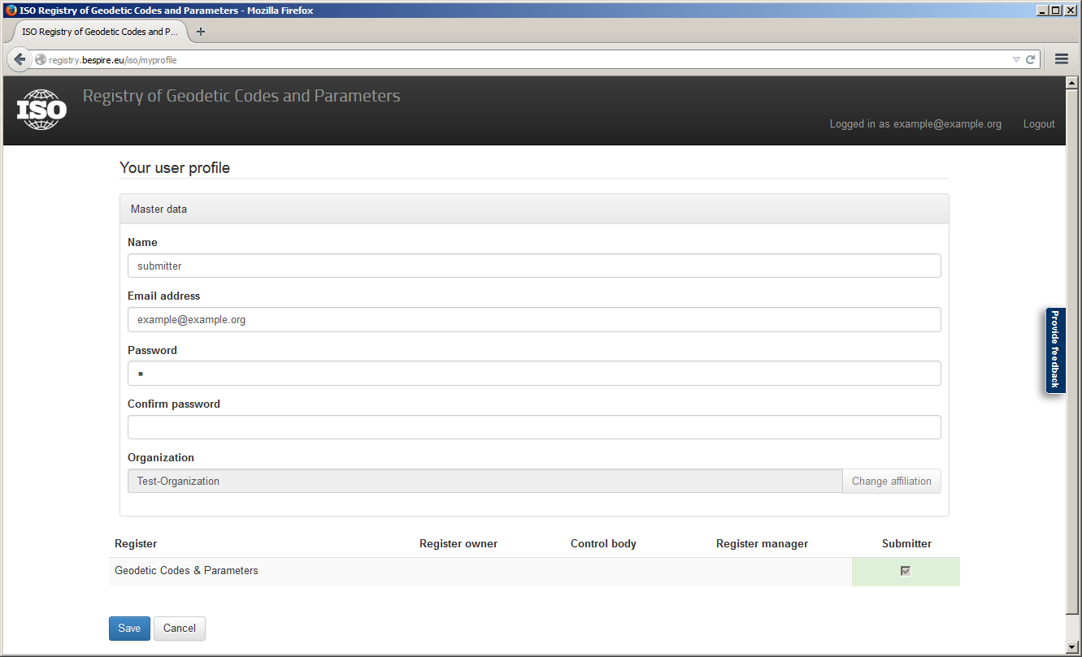

Fig. 5 - The user profile

Your user profile also contains a list of roles with regard to the registers inside the ISO Registry of Geodetic Codes and Parameters. For more details on roles, please consult the following section.

# Roles and processes in the registry

## Register roles

The ISO 19135 standard defines the following roles:

|  |  |
| --- | --- |
| Role | Description |
| Submitting organization | User/organization authorised by a register owner to propose changes to the content of a register |
| Control Body | group of technical experts that makes decisions regarding the content of a register |
| Register Manager | User/organization to which management of a register has been delegated by the register owner |
| Register Owner | User/organization that establishes a register |

In the ISO Registry of Geodetic Codes and Parameters these roles are directly assigned to organizations only. Organizations that were assigned a certain role may then (via their Point of Contact) delegate this role to registry users who then may act on the organization’s behalf.

## Additional roles

In addition to the standard roles, the following roles are part of the registry software:

|  |  |
| --- | --- |
| Role | Description |
| Administrator | Administrators have the right to manage registers, organizations and registry users. An administrator assigns register roles to organizations. The administrator role is global and not connected to a specific register or organization. |
| Point of Contact | The Point of Contact is an organization-related role and gives a user the right to delegate the roles held by his organization to other users of his organization. |

## Proposals

To submit new content to the ISO Registry of Geodetic Codes and Parameters, the following preconditions must be fulfilled:

1. You have created a user account (in the process you have either joined an existing organization or created a new one) and are logged in,
2. your organization was assigned the *Submitter* role by the registry administrator, and
3. the right to act as a Submitter was delegated to you by the Point of Contact of your organization (if you created the organization, you automatically become your organization’s Point of Contact).

If the aforementioned preconditions are fulfilled, you may now submit proposals to the register. There are four types of proposals that may be submitted:

|  |  |
| --- | --- |
| Type | Description |
| Addition | With an addition proposal you suggest a new register item to be inserted into the register that describes a concept which is not described by any other item already in the register. |
| Clarification | With a clarifications proposal you may correct errors in spelling, punctuation, or grammar for an existing item. A clarification shall not cause any substantive semantic or technical change to a registered item. |
| Retirement | Submitting organizations may submit requests for retirement of registered items that are no longer useful for producing data. A retirement causes a register item to be marked retired but not removed from the register. |
| Supersession | A supersession is a modification to a registered item that results in substantive semantic or technical change. It is accomplished by adding one or more new items into the register that supersede the original registered item. The original item remains in the register but is marked superseded and retains a reference to the item or items that superseded it. |

Creating a proposal is accomplished by clicking the respective action button (*Propose new*, *Clarify*, *Supersede*, or *Retire*) when browsing the content of a register.

## Registry processes

The following registry processes are defined by the ISO 19135 standard and are implemented in the registry software.

|  |  |
| --- | --- |
| Process | Description |
| Submission of proposals | Comprised of submission of new proposals by a submitting organization, review of completeness and initiation of the approval process by the register manager. |
| Approval process | Review of the proposal by the register’s control body. The control body decides whether to accept or reject the proposal. |
| Appeal | A submitting organization may appeal to the register owner if it disagrees with the decision of a control body to reject a proposal. The register owner decides whether to accept or reject the appeal and returns the result to the submitting organization and control body via the register manager. |
| Withdrawal | Submitting organizations may decide to withdraw a proposal at any time during the approval process. |

# Use cases in the registry

## Submitting new content

This section describes how to add a new item to the register by creating an *Addition* proposal. Please note that the other proposal types presented in the previous section are outside the scope of this document.

To create an Addition proposal, browse to the register content by clicking on the register name or on one of the contained item classes in the application menu and subsequently press on the *Propose new* button displayed above the register content.

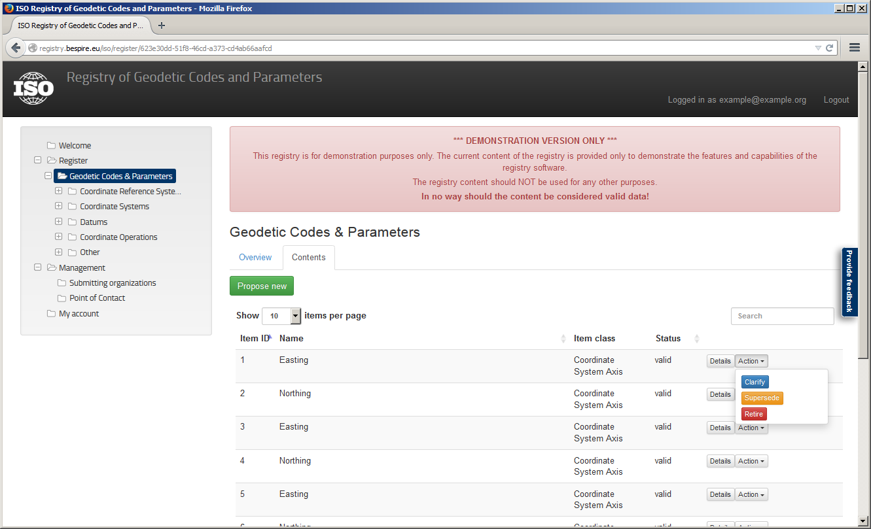

Fig. 6 - Browsing registry content

If you have clicked on a specific item class name, clicking *Propose new* will lead you directly to a proposal form for this item class. Otherwise you must select the item class of your proposal in the following dialog:

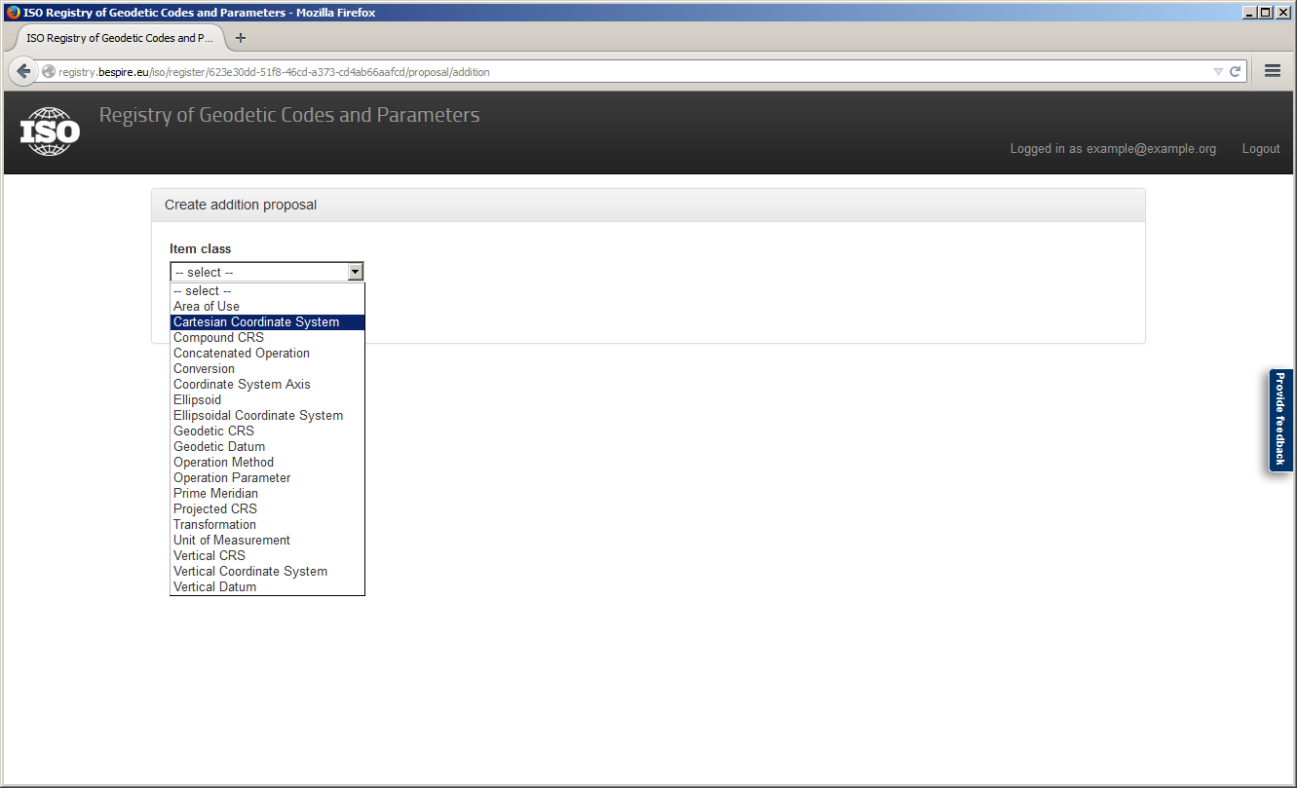

Fig. 7 - Select an item class for the proposal

Fill out the attributes and press the button *Submit proposal* to submit the proposal. You may also merely save the proposal (without submitting it) by pressing *Save proposal*. A saved proposal remains editable and may be submitted to the register at a later time.

Mandatory fields of the proposal are marked with the hand-left.png icon. If you omit to fill out a mandatory field, an error message will be displayed and the omitted fields are highlighted in red. Please note that the omitted field need not necessarily be in the current tab or accordion pane. If you are unsure why an error message is displayed, please make sure to check all tabs and accordion panes for omitted mandatory fields.

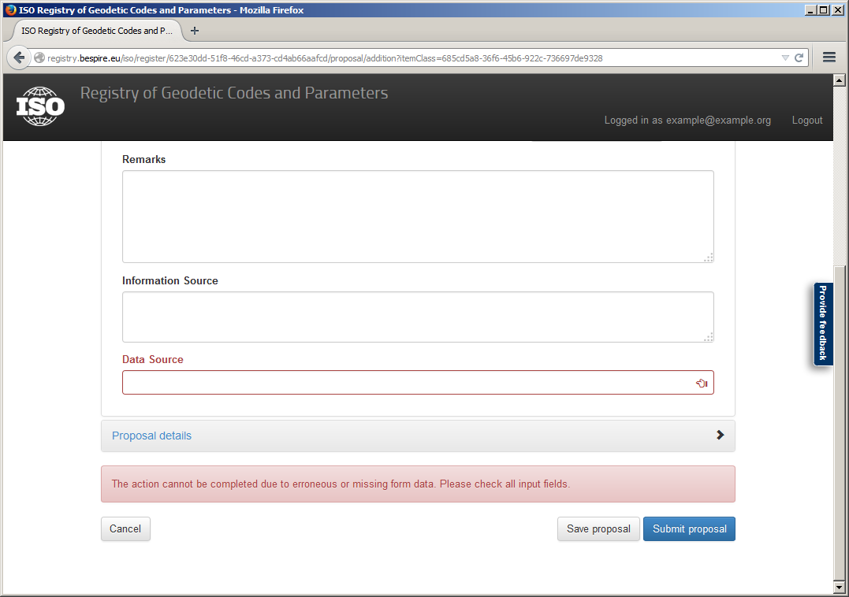

Fig. 8 - Error message on omitted mandatory field

## Withdrawing a proposal

A submitting organization may withdraw a proposal at any time by pressing the *Withdraw* button for the respective proposal on the submitting organization page (management area).

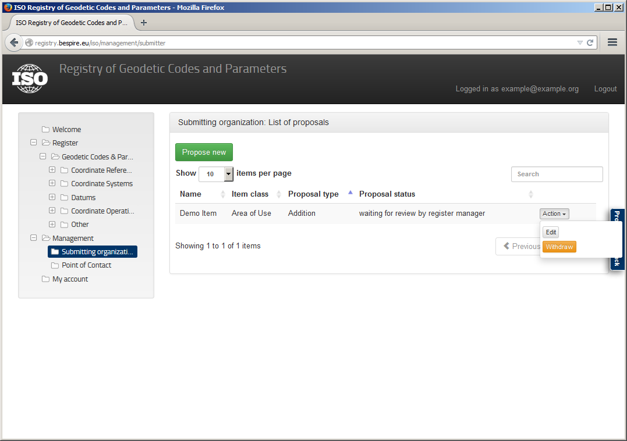

Fig. 9 - Submitting organization overview

## Proposal review by the register manager

After a new proposal has been submitted to a register, the register manager has to check the proposal for formal correctness, i.e. whether the proposal is formally valid and has reasonable content.

The register manager may review all proposals that are waiting for review by visiting the register manager page (management area).

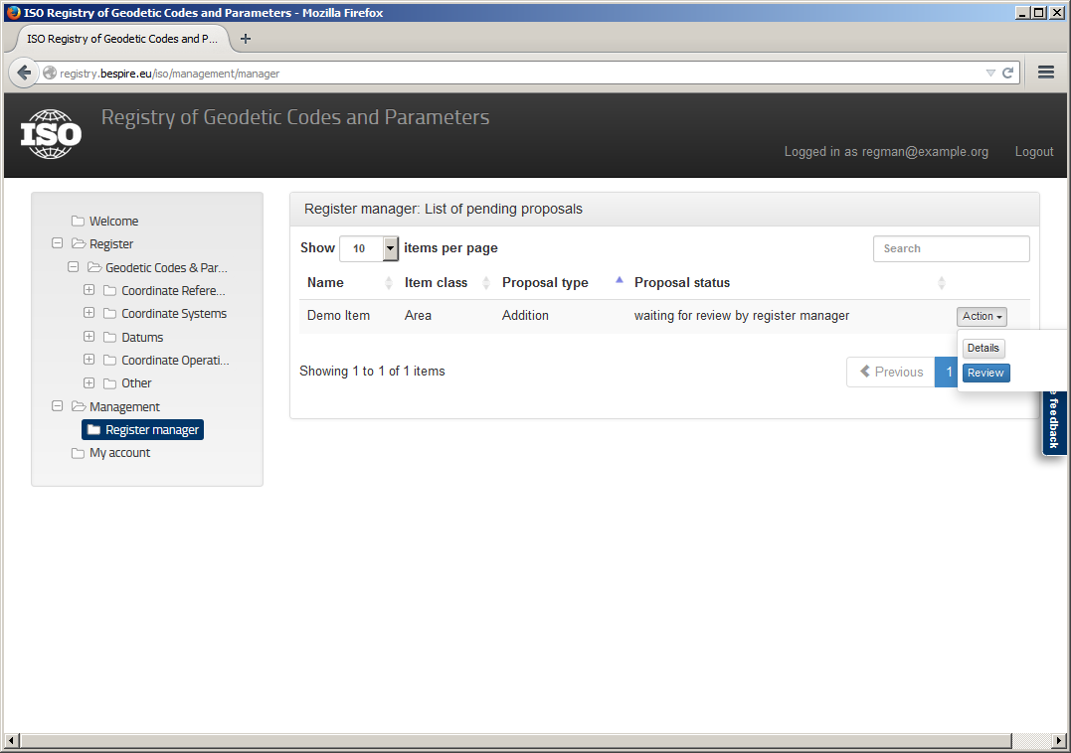

Fig. 10 - Register manager overview

To perform a review of a proposal, the register manager presses the *Review* button. He may then accept the proposal and hand it over to the control body for decision or he may return the proposal to the submitter for revision.

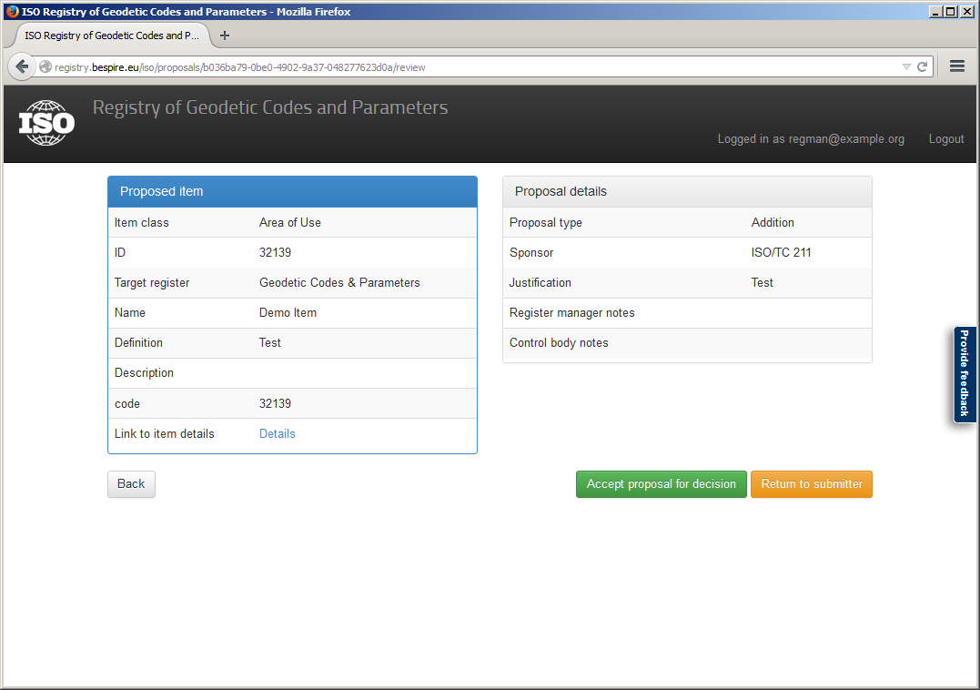

Fig. 11 - Reviewing a proposal as register manager

## Proposal review by the control body

If a proposal was accepted for decision by the register manager, the control body of the register must perform a thorough review of the proposal content. The control body then decides whether to accept the proposed register item into the register, to reject the proposal or to return the proposal to the submitter for revision.

A user who was delegated the role *Control Body* by his organization may review all proposals that are waiting for a decision by visiting the control body page (management area).

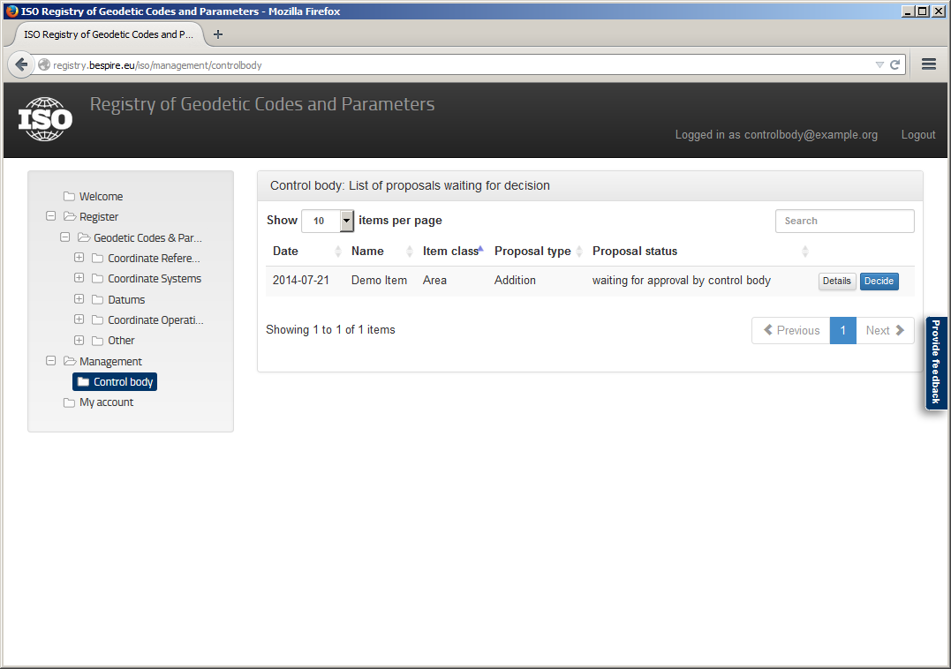

Fig. 12 – Control Body overview

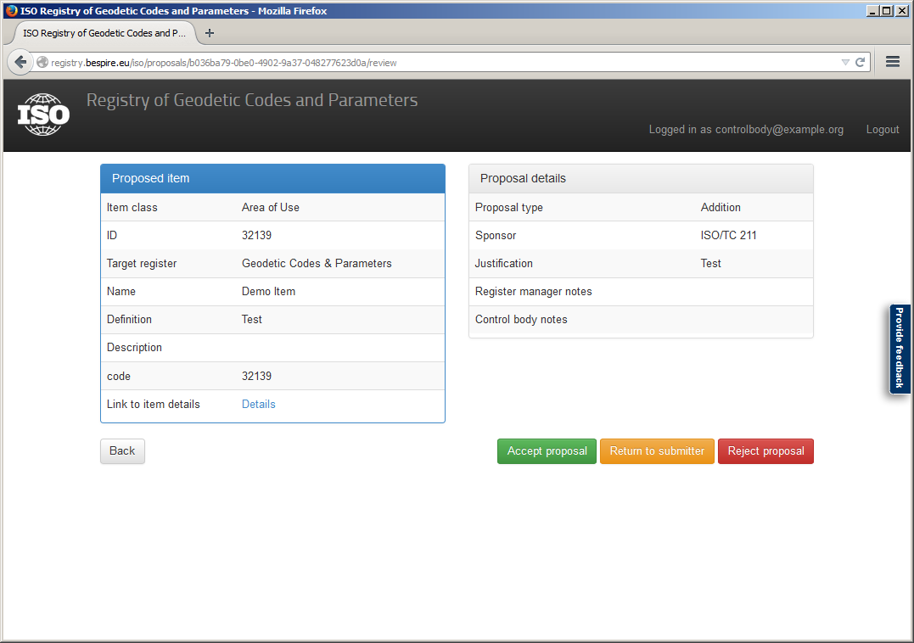

Fig. 13 - Reviewing a proposal as control body

## Appealing the control body decision

A submitting organization may appeal the rejection of the proposal by the control body to the register owner by clicking *Appeal to owner* on the rejected proposal. The submitter can see the status of all of his proposals and the open tasks by opening the submitting organization page (management area).

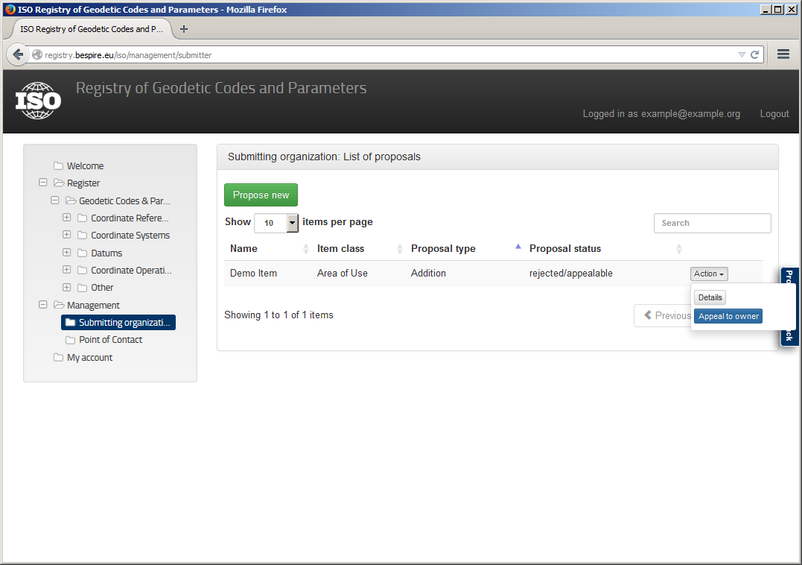

Fig. 14 - Appealing a rejected proposal

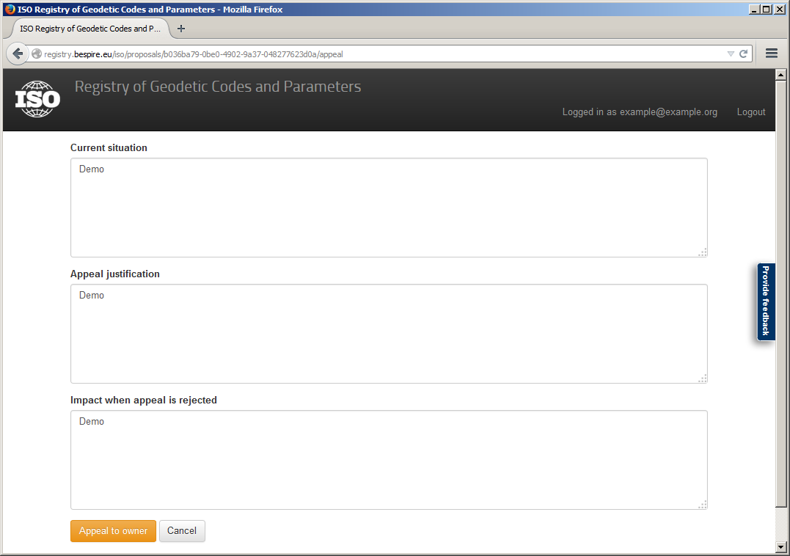

Fig. 15 - Preparing an appeal

# Registry administration

## Creating an organization

Lorem ipsum

## Assigning roles to organizations

Register-related roles as described in section 3.1 are primarily assigned to organizations only, i.e. a role (e.g. submitter

The administrators of the registry are responsible for assigning register-related roles to organizations.

Roles assigned to an organization are then delegated users affiliated to the organization. The delegation process is overseen by the organization’s Points of Contact.

## Delegating rights to users

The administrator has the right of altering the organization and user rights and roles. He able to create new organizations, edit existing organizations or delete them. The functionalities are placed on the *organization* or *user* page in the section *user management*.

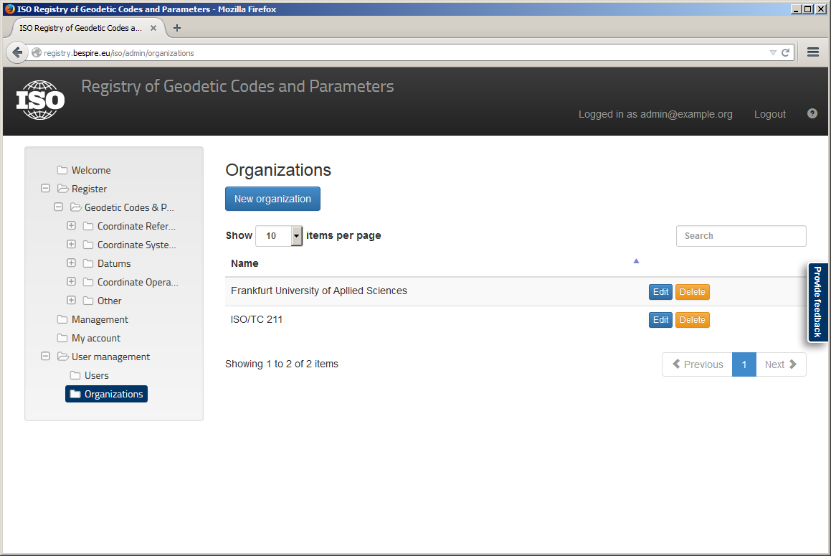

Fig. 16 – Organizations overview

In addition the administrator is able to delegate the register roles to the organizations and also the specific permissions to the users (see Fig. 18). Even the roles Point of Contact and the membership assignment can be delegated by the administrator.

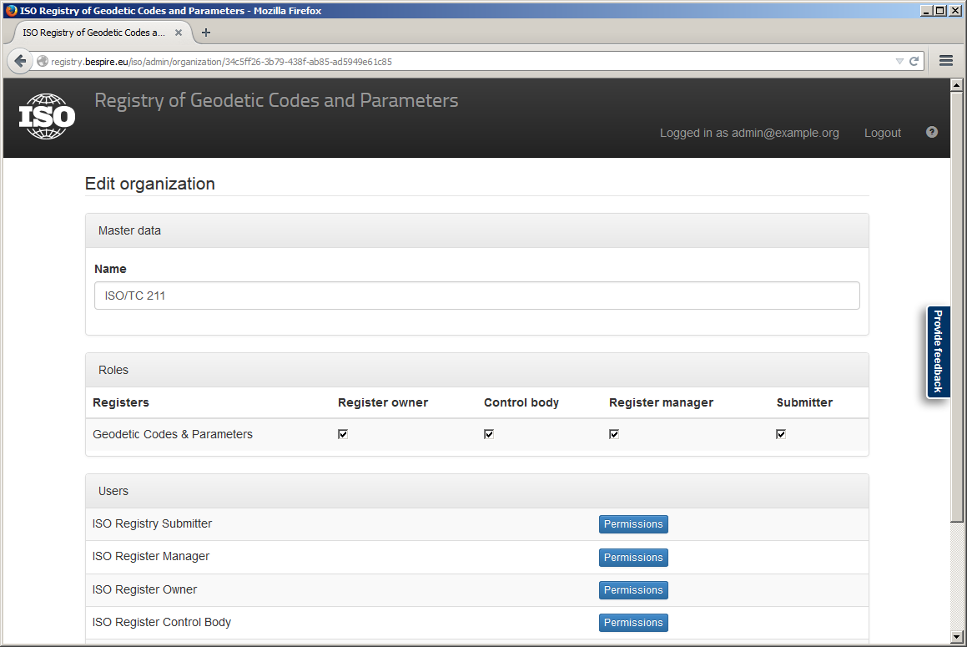

Fig. 17 – Delegating register roles to organizations

Users having the role *Point of contact* have the right to delegate all roles assigned to their organization to users affiliated with the organization. Additionally, a Point of contact is also responsible to confirm the membership for the new users and the delegation of the *Point of Contact* role to other users of the organization.

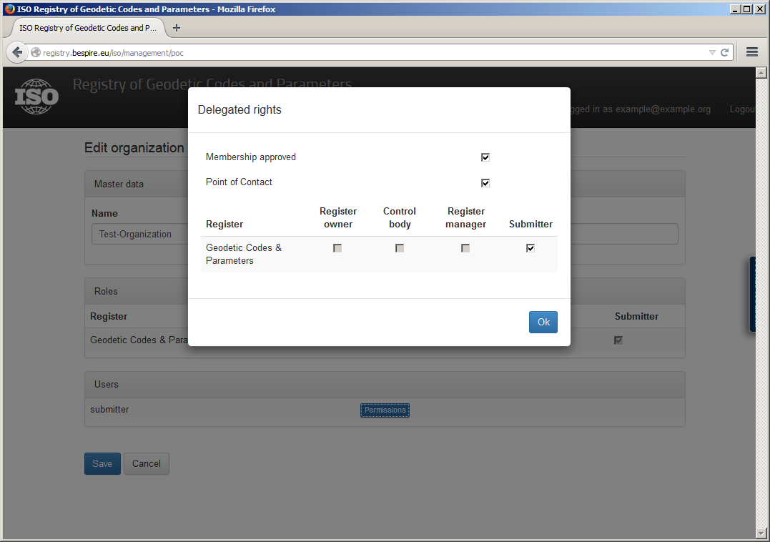

Fig. 18 - Delegating rights to a user

Users themselves may request specific user roles to the organization. Then the Point of Contact gets information about the request and can decide about it as described above.

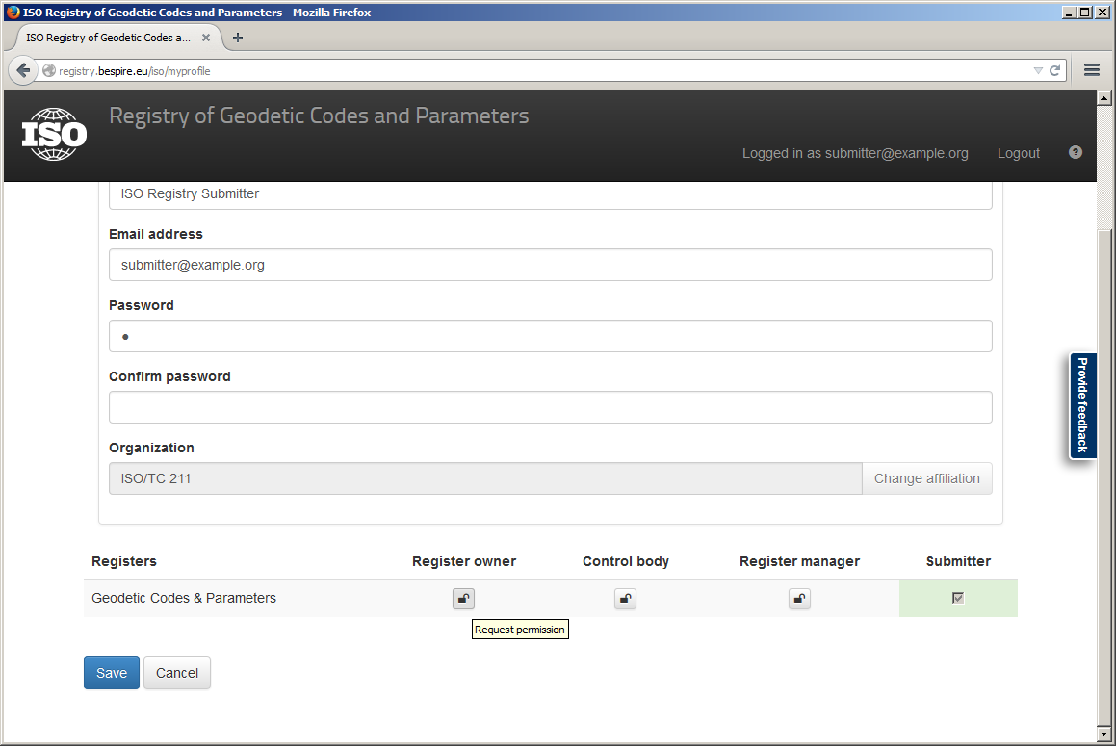

Fig. 19 – Request register roles by an user